JavaScript: Callback & Promise

1. Callback Function
Description: A callback function is a function passed as an argument to another function and executed later.
Code:
function processTask(callback){
console.log("Task started...");
callback();
}
function taskDone(){
console.log("Task completed!");
}
processTask(taskDone);
2. Promise (resolve & reject)
Description: A Promise represents a task that may complete in the future. It can be resolved (success) or rejected (failure).
Code:
function checkNumber(num){
return new Promise((resolve, reject) => {
if(num % 2 === 0){
resolve("Even number");
} else {
reject("Odd number");
}
});
}
3. Handling Promise (.then & .catch)
Description: Use .then() to handle success and .catch() to handle errors.
Code:
checkNumber(4)
.then(result => {
console.log(result);
})
.catch(error => {
console.log(error);
});

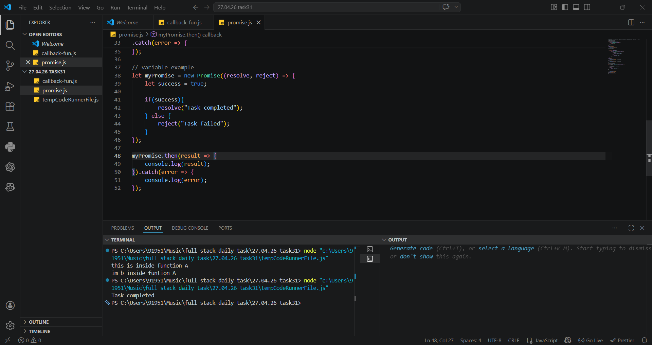
OUTPUT

